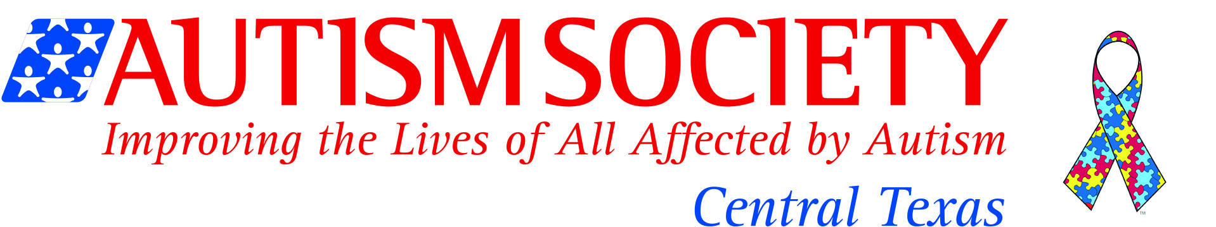

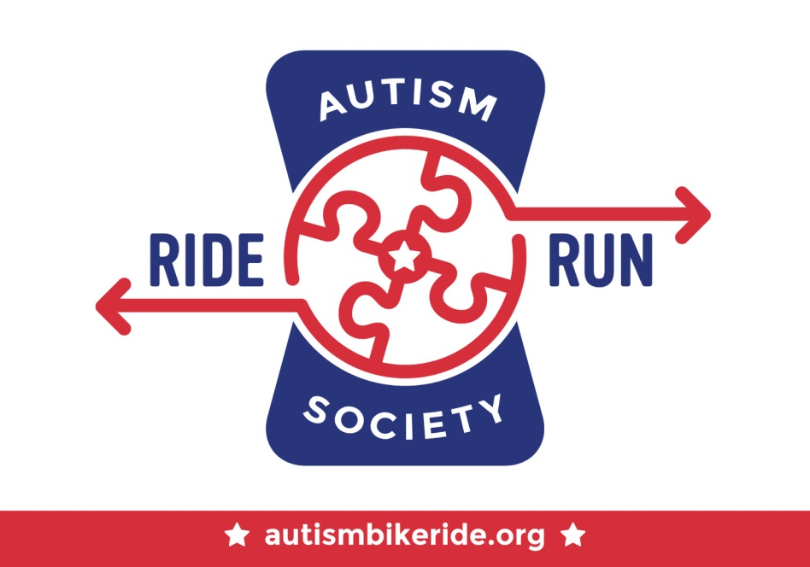

SPONSORSHIP PACKET
Saturday, April 11, 2015
Georgetown High School
Georgetown, Texas

ABOUT AUTISM
Autism is a developmental disability that usually appears in the first three years of life. Autism is a “spectrum disorder” meaning that it looks different in different people. In general though, people with autism typically have severe difficulties with communication, behavior, and social relationships. The incidence of autism has increased in recent years to an approximate occurrence of 1 in 68 births -- nearly twice as great as the 2004 rate of 1 in 125 – and almost 1 in 42 boys. Autism continues to receive more attention and as a result has opened opportunities for the country to consider how to serve families facing a lifetime of supports for their children.

FACTS AND STATISTICS
- More than 3.5 million Americans live with an autism spectrum disorder. (Buescher et al., 2014)
- Autism is the fastest-growing developmental disability. (CDC, 2008)
- The U.S. cost of autism over the lifespan is about $2.4 million for a person with an intellectual disability, or $1.4 million for a person without intellectual disability. (Buescher et al., 2014)
- 35 percent of young adults (ages 19-23) with autism have not had a job or received postgraduate education after leaving high school. (Shattuck et al., 2012)
- There is no known cure for autism; however, autism is treatable. Children do not “outgrow” autism, but studies show that early diagnosis and intervention lead to significantly improved outcomes.

ABOUT AUTISM SOCIETY OF CENTRAL TEXAS
The Autism Society of Central Texas is one of 106 affiliates of the Autism Society of America, the nation’s leading grassroots autism organization. We’re excited to announce our 25th Anniversary coming up in 2015! The Autism Society improves the lives of all affected by autism through information and referral services, support, recreation, education, and advocacy.

With the increase in prevalence of autism, the requests for help from our organization have also increased dramatically. The Autism Society responds to hundreds of inquiries from all over Central Texas each year about diagnosis, treatment, biomedical interventions, educational options, and local resources. We plan to use the proceeds from the Bike Ride to increase our capacity for disseminating information throughout the community. The Autism Society of Central Texas is a 501 (c) (3) nonprofit organization. Donations are tax-deductible to the fullest extent of the law.

ABOUT OUR AUTISM BIKE RIDE
The year 2015 will mark the Autism Society’s 7th Annual Autism Bike Ride. Not a cyclist but still wish to participate? This year, we’ll be adding a family fun run and walk! Our event will take place on Saturday, April 11, 2015 at Georgetown High School in beautiful Georgetown, Texas. Held during National Autism Awareness Month, this event celebrates awareness and acceptance. We expect 600 cyclists and several hundred friends, family members, and volunteers. All proceeds raised during the event stay local to directly help our families here in Central Texas.

SPONSORSHIP BENEFITS Your gift would be used to offset costs for the event. By helping us cover some of the ride’s expenses, you’ll help us direct most of the cyclists’ fees toward our mission.

King of the Road: $10,000
- Media Exposure including press release, sponsorship announcement, and feature article on our affiliate website and event page
- Your logo prominently on event poster, print ad, and event page
- Five (5) limited edition 2015 autism awareness cycling jerseys
- Your business logo prominently on our event banner
- Your logo with clickable link on our event page
- Prime location display space at Resource Fair (tent and table included)
- Opportunity to supply coupons, ads, and/or product samples for participants’ goody bags
- Five (5) official rider entries, including five (5) t-shirts and lunches
- Five (5) autism awareness ribbon lapel pins
- Social media and onsite recognition

Gold Jersey Sponsors: $5,000
- Your logo on event poster, print ad, and event page
- Four (4) limited edition 2015 autism awareness cycling jerseys
- Your business logo on our event banner
- Your logo with clickable link on our event page
- Display space at Resource Fair (tent and table included)
- Opportunity to supply coupons, ads, and/or product samples for participants’ goody bags
- Four (4) official rider entries, including four (4) t-shirts and lunches
- Four (4) autism awareness ribbon lapel pins
- Social media and onsite recognition
Family Fun Run & Walk
- Your company banner (provided by sponsor) placed at 3.1 mi walk area
- Additional $5,000 level benefits listed at the top.
Cycling Jersey Sponsor
- Company logo prominently placed on our limited edition 2015 autism awareness cycling jersey
- Additional $5,000 level benefits listed at the top.

Silver Jersey Sponsors: $2,500
- Your logo on event poster, print ad, and event page
- Three (3) limited edition 2015 autism awareness cycling jerseys
- Your business logo on our event banner
- Your logo with clickable link on our event page
- Display space at designated area and Resource Fair (tent and table included)
- Opportunity to supply coupons, ads, and/or product samples for participants’ goody bags
- Three (3) official rider entries, including three (3) t-shirts and lunches
- Three (3) autism awareness ribbon lapel pins
- Social media and onsite recognition
Resource Fair Sponsor
- Your company banner (provided by sponsor) displayed at Resource Fair
- See additional $2,500 level benefits at the top.
Food Pavilion Sponsor
- Your company banner (provided by sponsor) displayed at food pavilion
- See additional $2,500 level benefits at the top.
Start/Finish Line Sponsor: CLAIMED Thanks Central Texas Autism Center!
- Your company banner (provided by sponsor) displayed at start and finish line
- See additional $2,500 level benefits at the top.
Kids Play Area Sponsor: CLAIMED Thanks First Leap!
- Your company banner (provided by sponsor) displayed at kids area
- See additional $2,500 level benefits at the top.
Teen and Young Adult Area Sponsor
- Your company banner (provided by sponsor) displayed at teen/young adult area
- See additional $2,500 level benefits at the top.

Bronze Jersey Sponsors (Rest Stop or Aid Station): $1,000
- Your company banner (provided by sponsor) displayed at designated rest stop OR at Resource Fair (table and tent included at either)
- Option to meet and greet with families and cyclists
- Your logo on event poster, print ad, and event page
- Two (2) limited edition 2015 autism awareness cycling jersey
- Your business logo on our event banner (1/2 size)
- Your logo with clickable link on our event page
- Opportunity to supply coupons, ads, and/or product samples for participants’ goody bags
- Two (2) official rider entries, including two (2) t-shirts and lunches
- Two (2) autism awareness ribbon lapel pins
- Social media and onsite recognition

Breakaway: $500
- One (1) limited edition 2015 autism awareness cycling jersey
- Your BUSINESS NAME (not logo) with clickable link on our event page
- One (1) official rider entry, including one (1) t-shirt and lunch
- One (1) autism awareness ribbon lapel pin
- Social media and onsite recognition

Peloton (Family Sponsorship): $100
- Not offered to businesses or organizations
- Social media and onsite recognition (unless request to remain anonymous)

In-Kind and Media Sponsorships
Please contact us at bikeride@austinautismsociety.org for more information on in-kind and media sponsorships. Sponsorship benefits for in-kind donations will be decided based on item(s) value.

Volunteer Opportunities
Please email bikeride@austinautismsociety.org

Don’t see what you need? Contact bikeride@austinautismsociety.org

SPONSORSHIP FORM
Thank you for your consideration and support!
Please circle/highlight your sponsorship level.

Kings of the Road | $10,000 | Gold Jersey | $5,000
Silver Jersey | $2,500 | Bronze Jersey | $1,000
Breakaway | $500 | Peloton | $100

Company Name:
Contact Name and Title:
Sponsorship Level:
Street:
City, State, Zip:
Email:
Phone:

CONTACT: Please direct any questions to bikeride@austinautismsociety.org or call our office at (512) 479-4199.

PAYMENT: Autism Society of Central Texas is a 501(c)3 organization and your gift is tax-deductible. Please make checks payable to Autism Society of Greater Austin (old name acceptable) and mail to 4902 Grover Ave, Austin, TX, 78756. Online payments also accepted on our website under “Donate.”

FORM/LOGOS: Please email this form and high-res logos (only if logos are applicable and preferably .eps format) to Raine at raine@austinautismsociety.org. You may also mail this form to the address below.

Autism Society of Central Texas
4902 Grover Ave | Austin, TX 78756
Office (512) 479-4199
www.austinautismsociety.org

