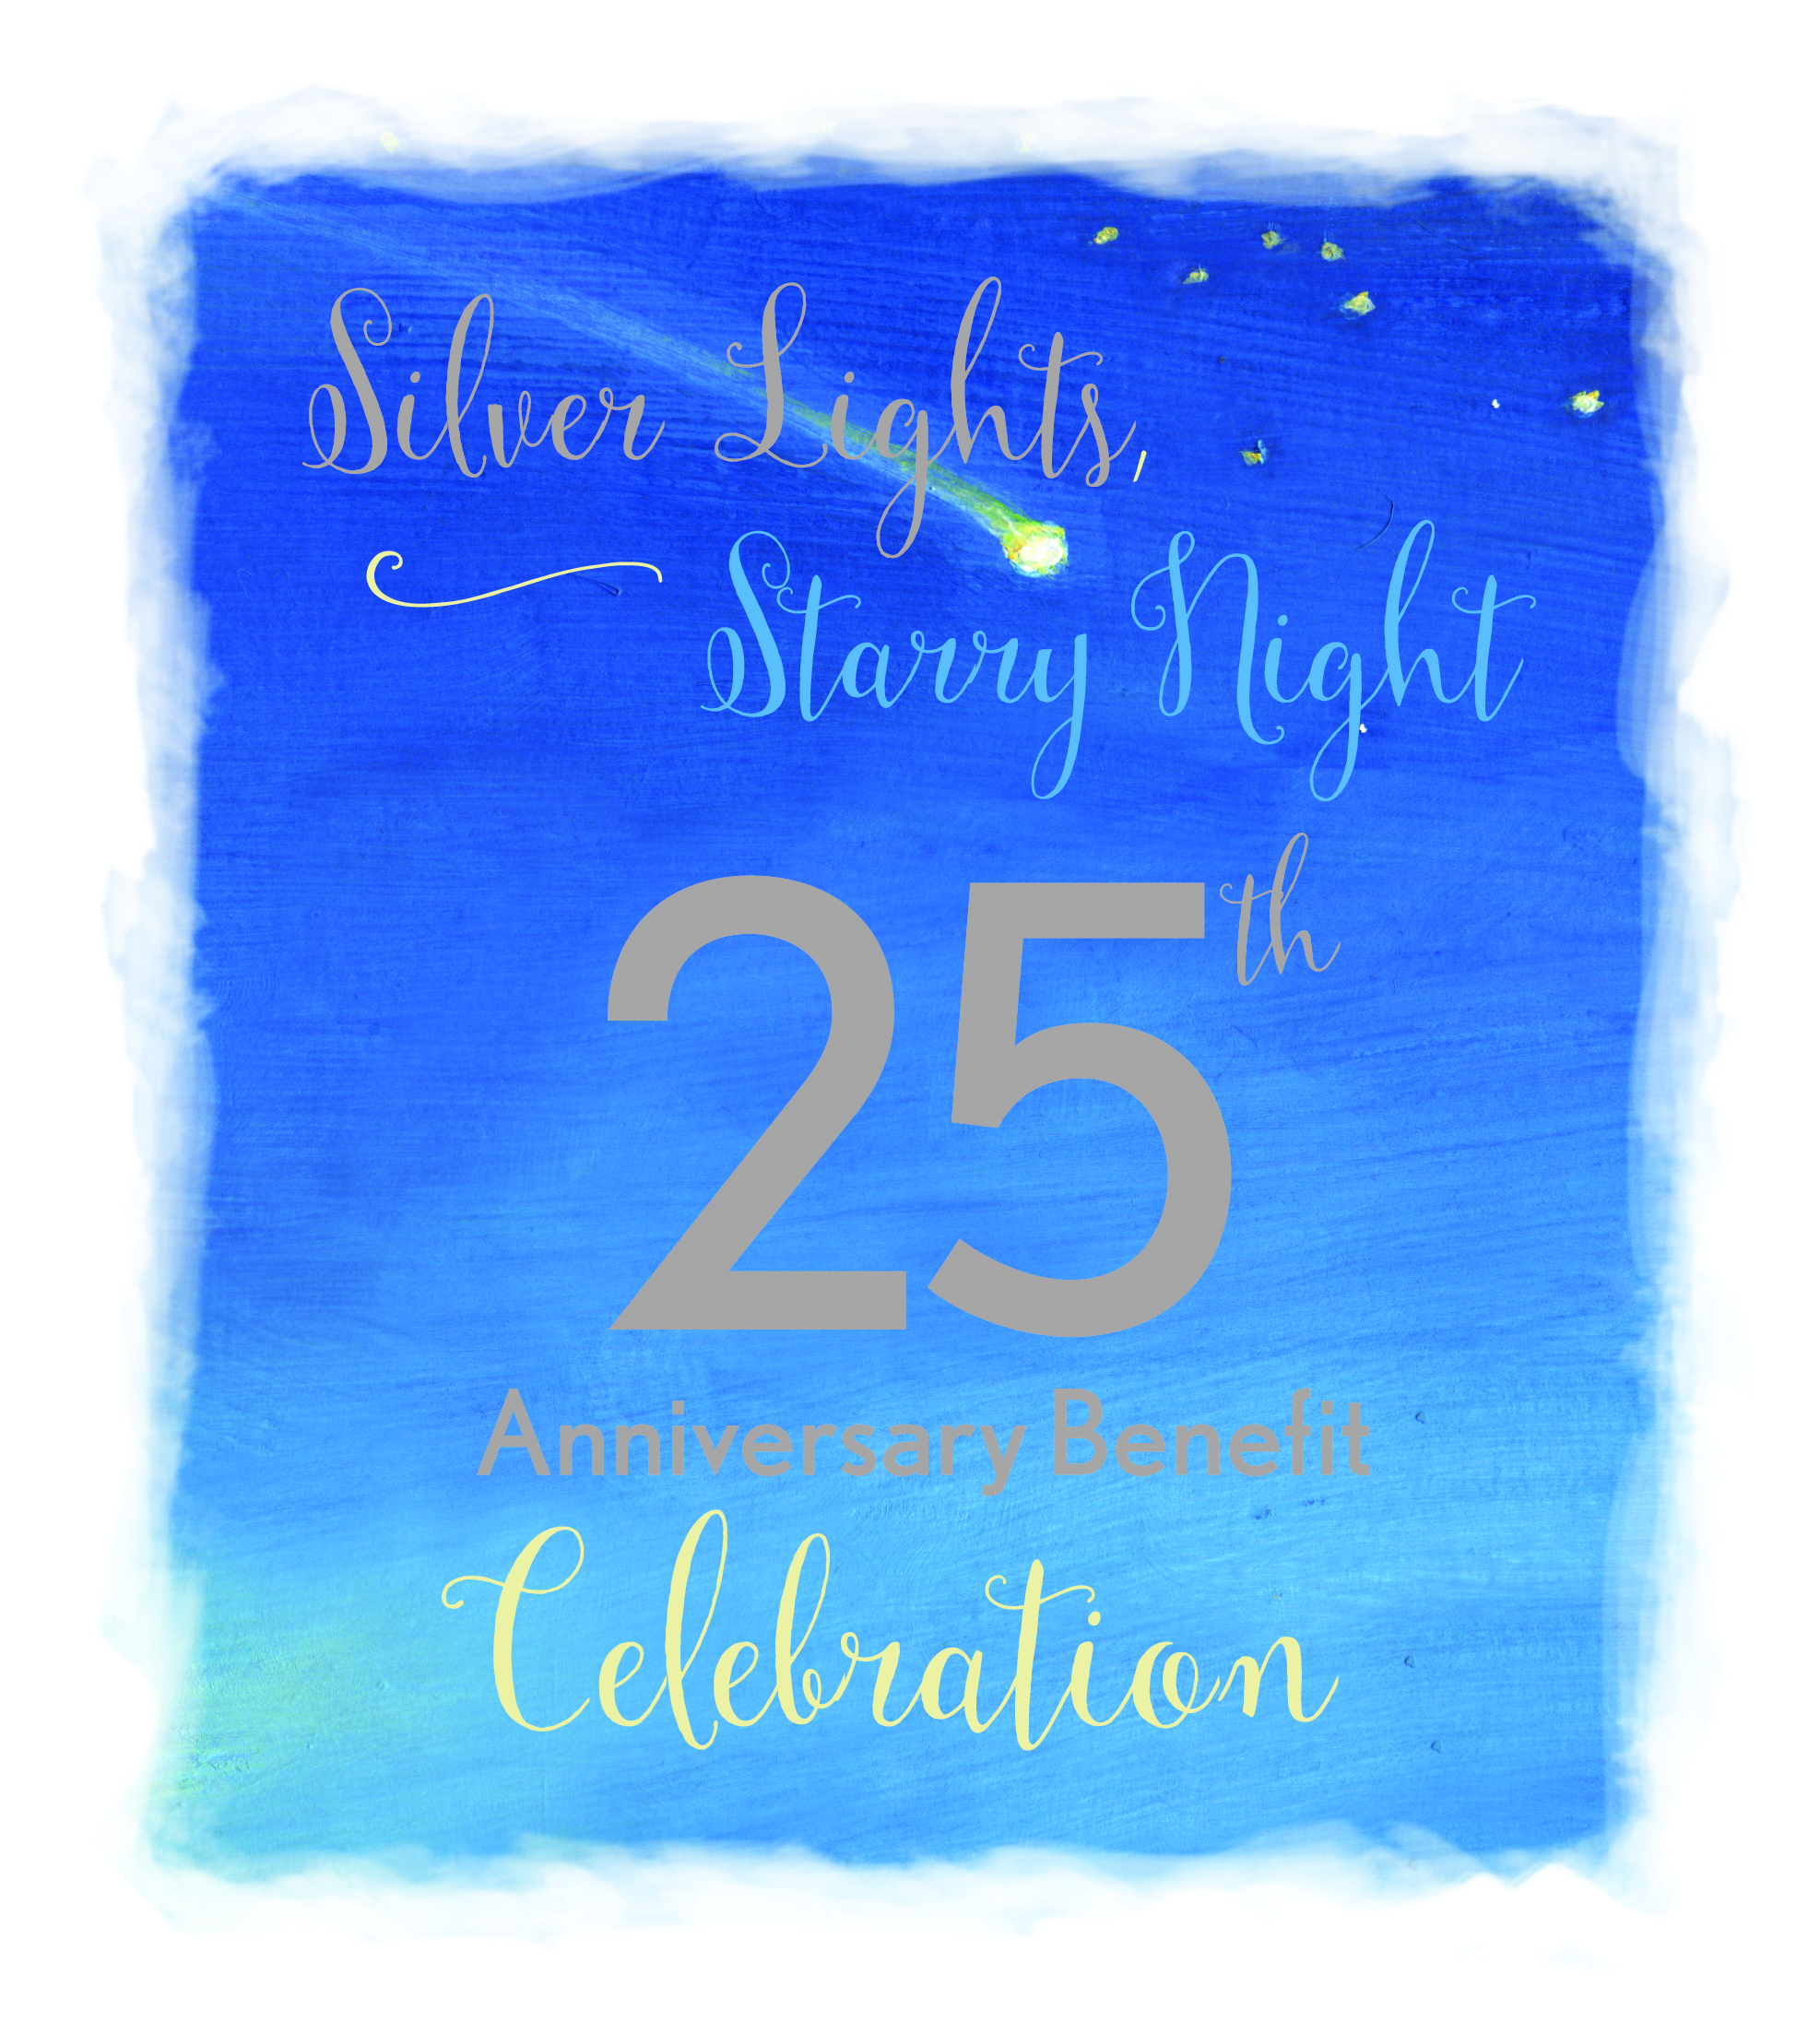
SPONSORSHIP PACKET
Silver Lights, Starry Night: 25th Anniversary Benefit Celebration
Saturday, November 14, 2015
7:00 p.m. – 10:00 p.m.
Brazos Hall
204 E. 4th Street
Austin, Texas

OUR MISSION

To improve the lives of all affected by autism

ABOUT AUTISM
- Neurological disorder that impacts speech, communication, social skills and fine/gross motor coordination
- Current incidence rate is 1 in 68 births, a nearly two-fold increase in the 2004 rate of 1 in 125, and it strikes almost 1 in 42 boys.
- Generally appears by the age of 3 years old; is the fastest growing development disability and this impacts all of us in some way, even if not directly.
- Autism causes severe difficulties with communication, behavior, social relationships and impairment in key areas that fall along a continuum.
- Access to individualized medical, educational and therapeutic interventions can significantly improve long term outcomes.

WHY BE A SPONSOR?
- Increase goodwill within your company with your employees: With the high incidence rate, chances are some of your employees know of or are directly impacted by autism.
- It creates an opportunity to reach other individuals and businesses possibly not being reached through your current marketing plan.
- Receive promotion and recognition, depending on the level of your sponsorship, on our in the press, on the radio, website, social media outlets, list serves, the event website, in printed material on event.

- Central Texans and especially families and professionals in the autism field are loyal to businesses that support autism that your truly care about families.
- It is a great way to show your support for the families and communities in Central Texas!

WHY IT SHOULD MATTER TO YOU
- Chances are an employee, client or customer has been touched by autism in their immediate or extended family or within their community and schools.
- Supporting this event lets your business prove they care about our Central Texas community.
- As a society, we all benefit when individual’s strengths are developed and children grow up to become as self-sufficient as possible.
- The cost of autism over the lifespan runs from $1.4 - $2.4 million depending upon the accompanying degree of intellectual disability (Buescher et al., 2014)
- As autism continues to receive more attention, we better understand the needs of and how to best support the needs of people with autism so that their strengths and talents are used as a foundation for improving their outcomes and overall quality of life.

WHO WE ARE/WHAT WE DO
- The oldest, largest & most active autism organization in Central Texas and 1 of 106 US chapters of the Autism Society of America.
- We respond to hundreds of inquiries from all over Central Texas and across the state each year from families, educators and other professionals about diagnosis, treatment, biomedical interventions, educational options, and local resources and services.
- Our list serv reaches over 1100 families throughout Central Texas on a daily basis and mailing list has over 2400 contacts.

- We facilitate and support list servs, support groups, recreational and educational opportunities throughout 24 counties of Central Texas (including larger cities like Austin, San Antonio, Bastrop, Taylor, Llano, Waco, etc.).
- We ensure the interests, needs, and capabilities of individuals with autism are well represented at the Texas Capitol and the Central Texas area.
- Your support will make a meaningful difference in the life of someone with autism.
- We are a 501 (c) (3) nonprofit organization. Donations are tax-deductible to the fullest extent of the law.

ABOUT OUR SILVER ANNIVERSARY EVENT
Help us celebrate 25 years of improving the lives of people impacted by autism with great food prepared and served by Pink Avocado, a beautiful roof top setting in downtown Austin, exotic and fun belly dancers from Gypsy Eyes, a ring toss for the chance to win special prizes, a photo booth with props and costumes, a silent auction of unique gifts, a raffle of an Austin-themed work of art by renowned artist Carlos E. Ortiz, and the evening promises to be one to remember!

Our guests will have a great time all the while knowing they are helping increase our current outreach and support to individuals with autism. Funds raised will also help expand services and resources to students transitioning out of the public school system and into adulthood to increase employment options for these students.

We look forward to our Silver Anniversary Celebration being a fun event that brings together families, professionals, businesses, and community members who share the belief that every person with autism deserves access to the supports has skills and abilities enabling them to contribute to their community in meaningful ways.

SPONSORSHIP PERKS

Sponsorship Benefits | $5000 | $3000 | $2000 | $500 | $25-$499
Media Exposure including mention in press release, ads, sponsorship announcements, and other promotions | x | x | x
Social Media Recognition | x | x | x | x
Gratis Event Ticket(s) | 4 | 2 | 2 | 2
Additional Drink Ticket(s) per Event Ticket | 3 | 2 | 1 | 1
Signage & Verbal Recognition at the event | x | x | x | x
Written recognition at event | x | x | x | x | x
Your Logo on ASCT (1 year) and event website | x | x | x | x
Link to your website from our website (1 yr) | x | x

IN-KIND and MEDIA SPONSORSHIPS
Please contact us at info@austinautismsociety.org for more information on in-kind and media sponsorships. Sponsorship benefits for in-kind donations will be decided based on item(s) value.

VOLUNTEER OPPORTUNITIES
Cannot make a financial donation this year? Please consider volunteering to help organize and run this event – we have many options to be considered. Contact us at info@austinautismsociety.org!

SPONSORSHIP FORM
Thank you for your consideration and support! Please indicate your sponsorship level below:

Sponsorships | $5000 | $2000
 | $3000 | $500
Donation Amount $__________ | 2016 Commitment $__________________ | $25-$499

Company Name:
Contact Name and Title:
Sponsorship Level:
Street: City, State, Zip:
Email: Phone:
CONTACT: Please direct any questions to info@austinautismsociety.org or call our office at (512) 479-4199.
PAYMENT: Autism Society of Central Texas is a 501(c)3 organization and your gift is tax-deductible. Please make checks payable to Autism Society of Central Texas and mail to 4902 Grover Ave, Austin, TX, 78756. Online payments also accepted on our website under “Donate”, but please also send this form and your logo via e-mail.
FORM/LOGOS: Please email this form and high-res logos (only if logos are applicable and preferably .eps format).

