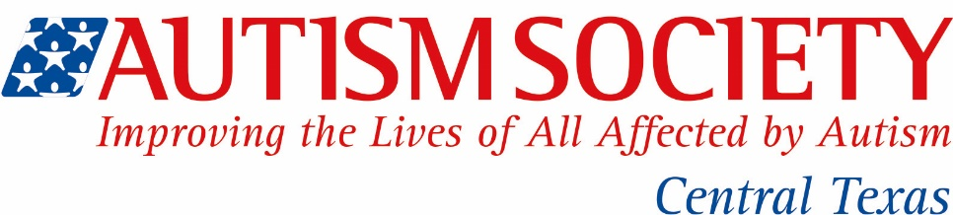

FOR IMMEDIATE RELEASE CONTACT: AUTISM SOCIETY of Central Texas
Suzanne Potts
512-479-4199
Suzanne@austinautismsociety.org

The Autism Society of Central Texas Board Member wins 2015 National Volunteer of the Year Award

Austin, TX June 14, 2015; We are pleased to announce that Ann Hart, Past President, Board Member and Information and Referral volunteer, has been selected to receive the National 2015 Autism Society Volunteer of the Year award. This prestigious award is given to an individual who has made a significant contribution to the autism community.
“The Autism Society of Central Texas so grateful to Ann and the hard work that she has done with our organization. We could not have managed our day to day operations without her input, skill and tremendous autism knowledge. She has singlehandedly helped hundreds of families and individuals navigate autism, from those newly diagnosed to helping adults with autism lead productive, rewarding lives.” Suzanne Potts, Executive Director.
Ann will be receiving her award this summer at the Autism Society of America National Conference held July 8-11, in Denver, Colorado. The Autism Society’s annual conference represents one of the largest gathering of autism families, service providers, educators, policymakers and key allies in the disability community with over 100 breakout sessions.
The Autism Society is the nation's largest and oldest grassroots autism organization. Founded in 1965, the Autism Society and its national network of local affiliates is dedicated to improving the lives of those living with autism, supporting families and communities, and ensuring that individuals lead lives that include acceptance, dignity, and independence to the greatest extent possible.
As one of over 100 local affiliates, the Autism Society of Central Texas has supported families and individuals with autism for over 25 years here in Texas and is dedicated to improving lives in our community through a series of services and supports. The Autism Society of Central Texas is proud of our programs and initiatives and the contributions we make to our community:
- Information and Referrals
- Support
- Education and Training
- Advocacy
- Awareness
- Recreational opportunities
For more information about autism and the Autism Society, please visit: www.austinautismsociety.org.

####

