Quick Guide Calendar Submission

Thank you for reviewing our quick guide! As we grow, this calendar submission system will help the Autism Society of Central Texas cut down on time spent manually posting events to the calendar and create more time for activities key to our mission such as support, information and referral, recreation, advocacy and education.

Generally, Autism Society will approve submissions that are free or low cost resources for individuals with autism and their families. We will not promote another organizations fundraisers or direct sales opportunity unless it is a resource to our families. We will not post materials, supplements or any item that promotes a “cure” for autism. We are here to promote support and services for individuals and families living with autism throughout the many stages of life.

Step 1: Go to www.austinautismsociety.org

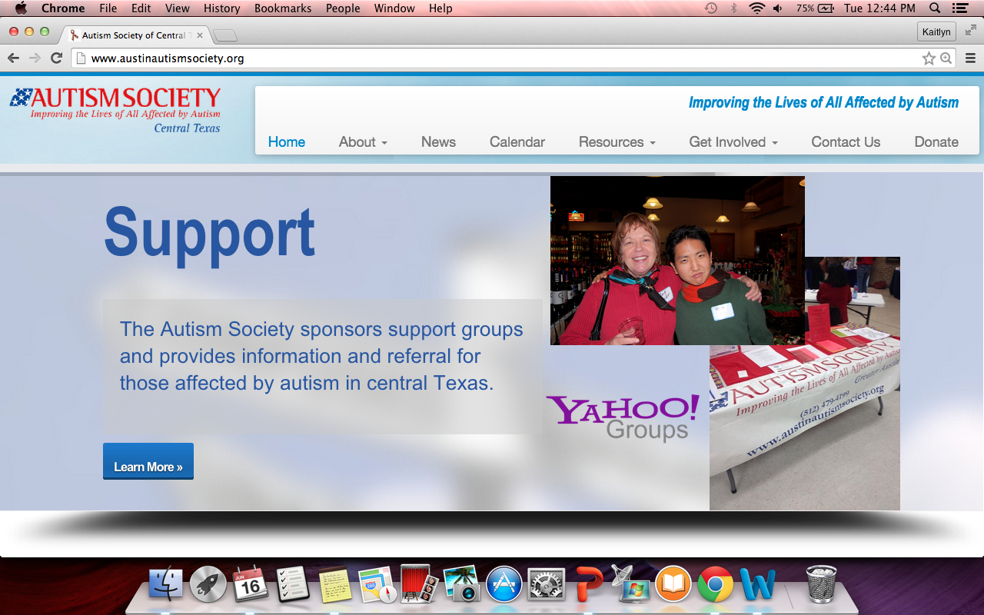

Step 2: Go to the “Calendar” tab and click on the green “Post Your Event” tab in the right-hand corner above the calendar.

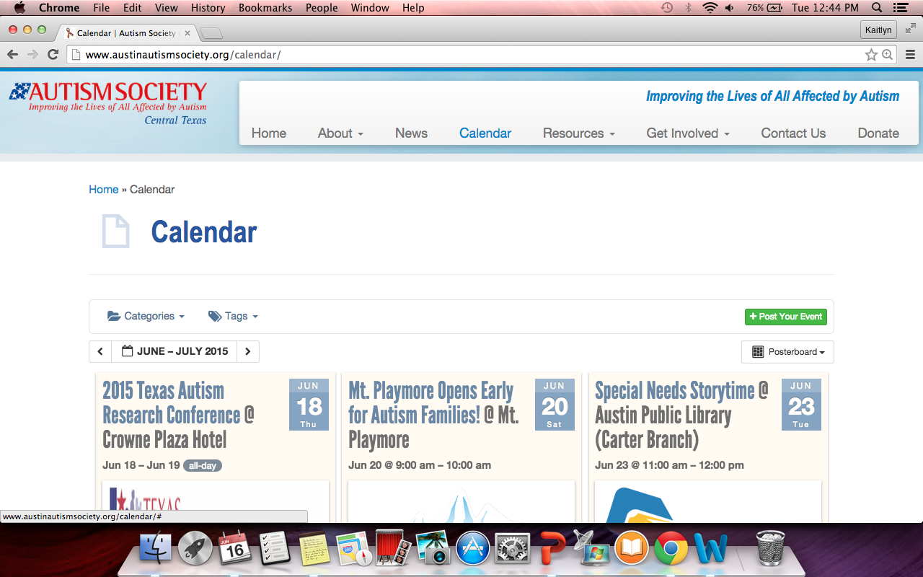

Step 3: Fill out the “Post Your Event” submission form with all information relevant to your event.

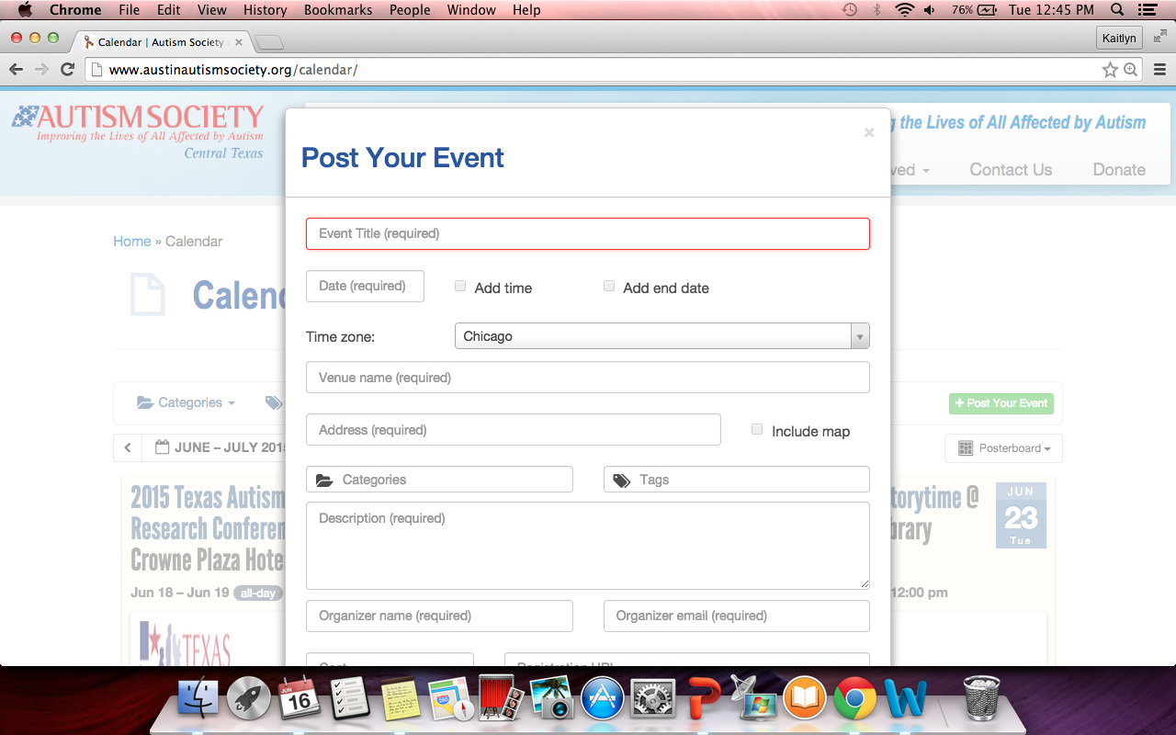

Step 4: Hit the green “Submit Event” tab!

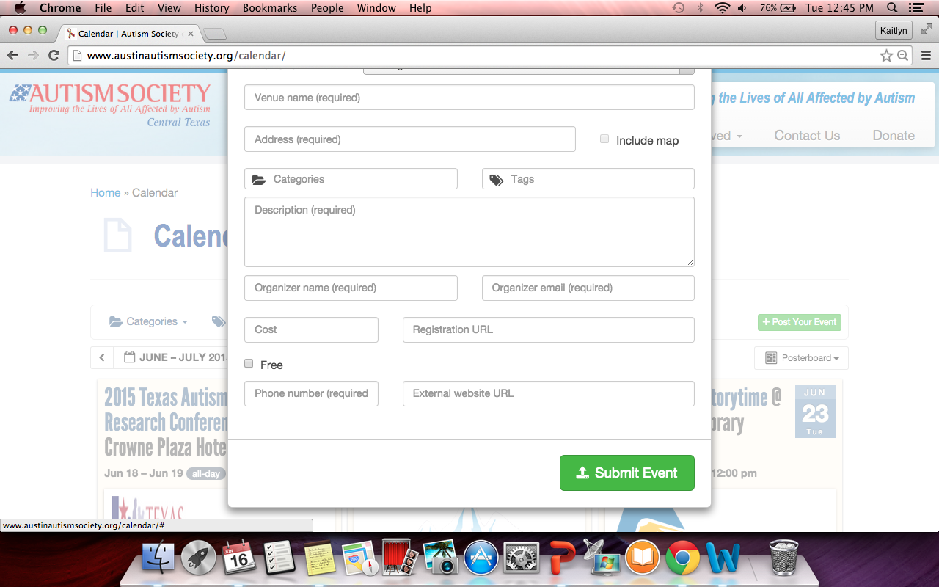

Step 5: If you have any edits to make to your event posting, please email us at admin@austinautismsociety.org!

Thank you for sharing your event with our autism community and we look forward to promoting this with our network of over 2500 individuals with autism, their families and the community. If you have any questions or concerns, please email us at admin@austinautismsociety.org or call 512-479-4199.

